Facebook Services

- The Social Graph — The Facebook social graph is made up of users and their direct or indirect relationships. Direct relationships include meeting someone at a party or through a business connection. Indirect relationships could include a social, educational, or regional network.
- User Profiles — Information about users is available through user profile pages. These pages include user-generated content, as well as information derived from the social graph. These pages make this information available to other users. In addition, there are also hints about the users’ activities within Facebook, including photos they are in and groups they have joined. User profile pages include the different ways to communicate with other users through message links and a profile Wall where users can post one-off messages to each other.
- Messaging — Messaging includes user-to-user messages, as well as general notifications.
- Pages — Facebook Pages are one of the more recent additions to Facebook. Pages are a way to create a sort of profile for a business, band, or product that can be managed and modified by one or more Facebook users. A Facebook Page allows Facebook users to interact with the page’s subject by becoming a fan or by using the message board.
- Information Aggregates — With all of the information available on Facebook, sorting out what users are really interested in is a job in and of itself. This is done through information aggregates such as the News Feed or Mini-Feed (available on the Facebook home page), or the user profile pages.

The Standard Web Application Model
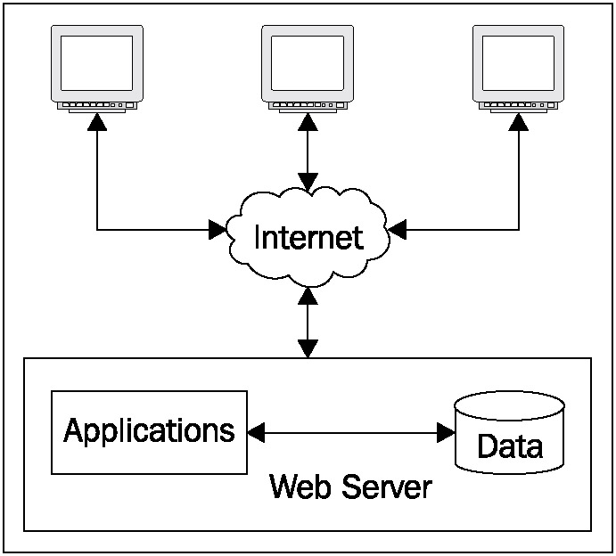

The Facebook Web Application Model
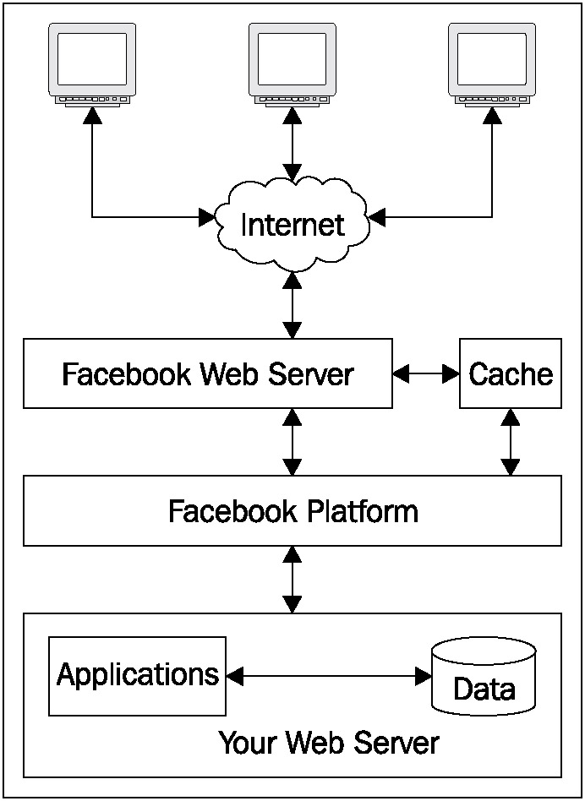

The Technology behind Facebook
Facebook is built on open-source software. Some of the open-source technologies used by Facebook include Apache, PHP, MySQL, and memcached. For more information about the open source technologies used on Facebook, please visit http://developers.facebook.com/opensource/

The Core Technologies

Facebook Platform has four main duties:

- Provide uniform and consistent methods to exchange information between itself and third parties.

- Manage relationships between users.

- Provide methods to distribute content on different mediums.

- Provide methods of interaction between users

Four components to be concerned with in application development:
- Application Program Interface (API) — The Facebook API is a collection of REST methods that allow developers to exchange information with the Facebook Platform.

- Facebook Markup Language (FBML) — This is a markup language designed to provide developers and designers with a quick medium to create clean and uniform interfaces.

- Facebook Query Language (FQL) — This is a SQL-like query language to mine data from the Facebook Platform.

- Authentication

Role of the Facebook Application

For Facebook: applications on Facebook are the key pieces that turn Facebook into a social platform. They have a direct impact on the users and, as the Platform continues to grow, they will play a pivotal role in the growth of Facebook as a whole. The applications available help transition users from using web sites into using web operating systems.

For other companies: the real shift is the total cost of building, releasing, and maintaining your web applications versus creating a Facebook application. More and more, developers and companies are looking at what it takes to create a full web application, acquire users, and add new features, instead of creating a Facebook application that can be just as feature-rich, as well as offering a reliable user base and platform to build upon. Facebook provides the building blocks and the users.

Application Request Process
Facebook treats all applications as modular plug-ins that Facebook interacts with. Facebook does not host the applications, nor do the applications live on the Facebook network. Therefore, there is a strict request process that all applications must conform to.

- The user accesses the Application

- Facebook sends a POST request to a URL based on the Callback URL provided in the Application configuration.

- The application parses the POST body and validates the POST signature.

- The application performs its actions and generates markup for Facebook to display.

- Facebook analyzes the markup (FBML) provided and renders it to the user’s browser.

When a user accesses the application through the Application Canvas, the following parameters will always be included:

- fb_sig_in_canvas — With a value of 0 or 1, this indicates that the request was made through the Facebook Canvas.

- fb_sig_added — With a value of 0 or 1, this indicates that the requesting user has added the application.

- fb_sig_time — This is the current time in seconds since UNIX Epoch.

- fb_sig_api_key — This is the API key of the application.

- fb_sig — This parameter is used to verify that the request came from Facebook. See the section, “Validating the Request Signature,” below in this chapter for more information on validating this parameter.

Users who have already granted access to your application trigger the following POST parameters to be sent in addition to those already mentioned:

- fb_sig_user — The numeric ID for the requesting user

- fb_sig_friends — A comma-separated list of user IDs (UIDs) that the requesting user has as friends

- fb_sig_session_key — The current session key tied to the application and requesting user

- fb_sig_profile_update_time — The time in seconds since the last update that the requesting user made to the user’s profile

The different combinations of request arguments lead to four different Canvas page request types:

- Requests where the user is logged into Facebook, but the requesting user has not granted access to the application. This is represented by the absence of a fb_sig_user parameter.

- Requests where the user is logged into Facebook and has granted access to the application but has not added the application. This is indicated when the fb_sig_added parameter is set to 0.

- Requests where the user is logged into Facebook, has granted access to the application, and has added the application. This is indicated when the fb_sig_added parameter is set to 1.

What You Need to Develop a Facebook Application?

- A Facebook account
- A web server to host the application

How to Create a Facebook Application?

- Set up a new application
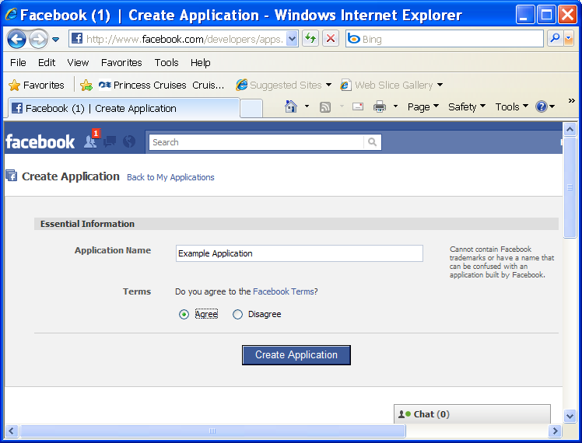

2.

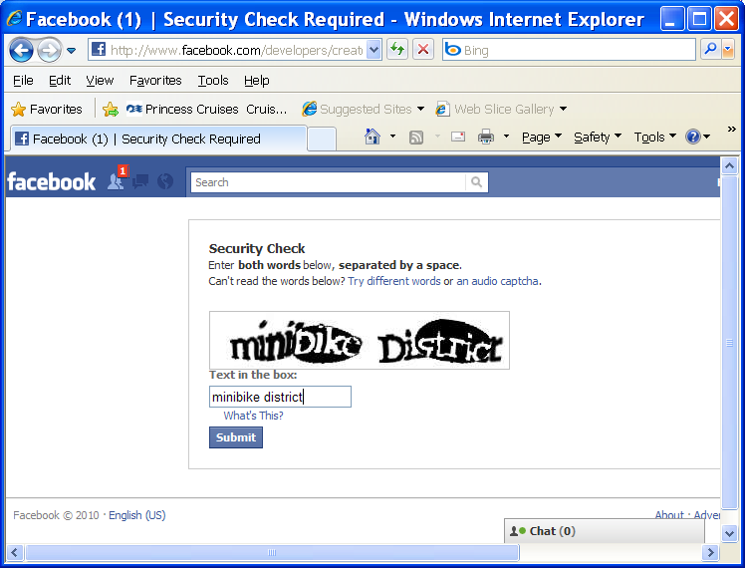

- Enter basic information

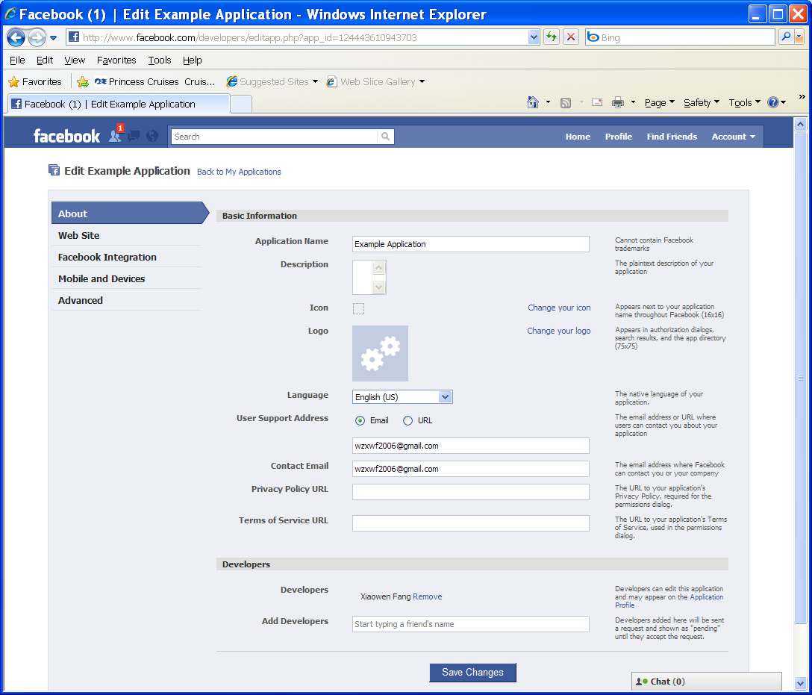

- Set up the web site and Facebook integration points.
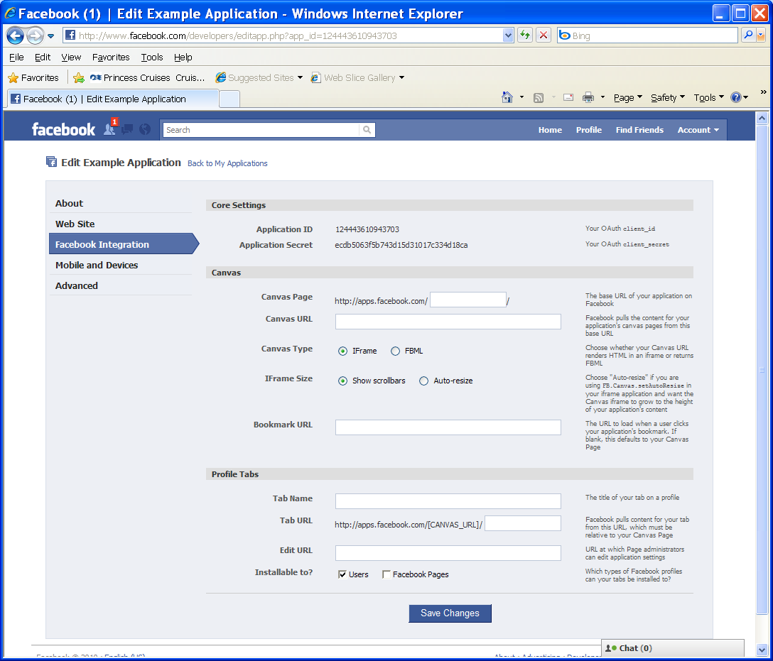

For more detailed instructions, please see the notes “How to create a Facebook application?” or visit http://developers.facebook.com/docs/guides/canvas/

Facebook Markup Language (FBML)

FBML is a strict markup language that is made up of XML entities to deliver a rich experience to Facebook users. Please visit http://developers.facebook.com/docs/reference/fbml/ for more information about FBML.

Graph API

The Graph API is the core of Facebook Platform, enabling you to read and write data to Facebook. It provides a simple and consistent view of the social graph, uniformly representing objects (like people, photos, events, and pages) and the connections between them (like friendships, likes, and photo tags).

More information can be found at http://developers.facebook.com/docs/reference/api/
More information about FQL (Facebook Query Language) can be found at http://developers.facebook.com/docs/reference/fql/

An example of using Graph API:
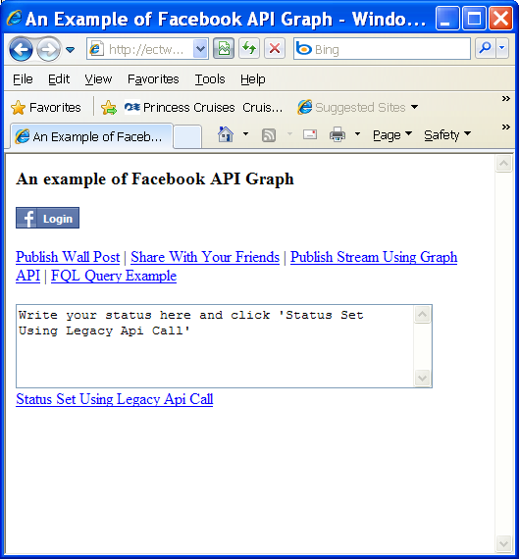  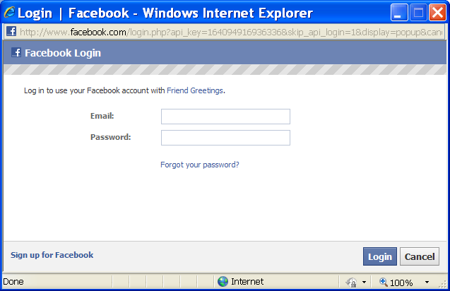  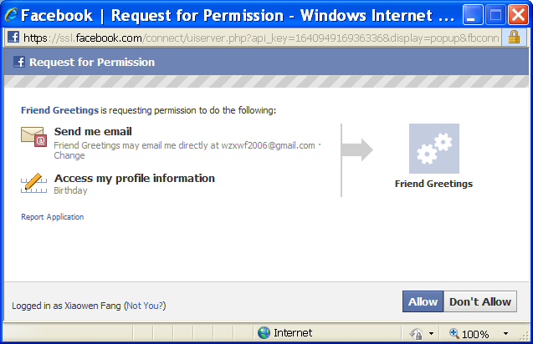  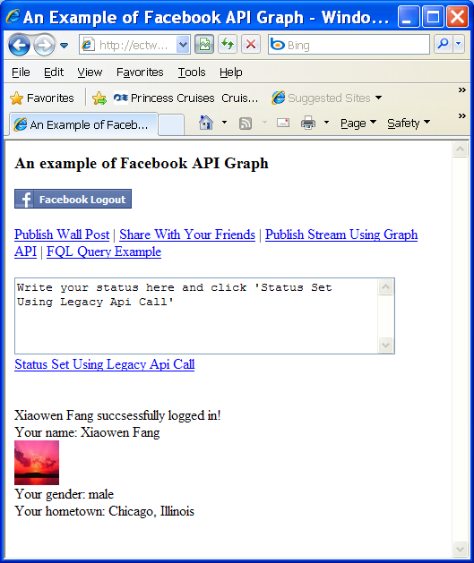 | Facebook/graphapi.php  <!DOCTYPE html>  <html xmlns="http://www.w3.org/1999/xhtml" xmlns:fb="http://www.facebook.com/2008/fbml">  <head>  <meta http-equiv="Content-Type" content="text/html; charset=UTF-8"/>  <title>An Example of Facebook API Graph</title>  </head>  <body>  <div id="fb-root"></div>  <script type="text/javascript">  window.fbAsyncInit = function() {  FB.init({appId: '164094916936336', status: true, cookie: true, xfbml: true});  /* All the events registered */  FB.Event.subscribe('auth.login', function(response) {  // do something with response  login();  });  FB.Event.subscribe('auth.logout', function(response) {  // do something with response  logout();  });  FB.getLoginStatus(function(response) {  if (response.session) {  // logged in and connected user, someone you know  login();  }  });  };  (function() {  var e = document.createElement('script');  e.type = 'text/javascript';  e.src = document.location.protocol +  '//connect.facebook.net/en_US/all.js';  e.async = true;  document.getElementById('fb-root').appendChild(e);  }());  function login(){  FB.api('/me', function(response) {  document.getElementById('login').style.display = "block";  document.getElementById('login').innerHTML = response.name + " succsessfully logged in!";  });  }  function logout(){  document.getElementById('login').style.display = "none";  }  //stream publish method  function streamPublish(name, description, hrefTitle, hrefLink, userPrompt){  FB.ui(  {  method: 'stream.publish',  message: '',  attachment: {  name: name,  caption: '',  description: (description),  href: hrefLink  },  action_links: [  { text: hrefTitle, href: hrefLink }  ],  user_prompt_message: userPrompt  },  function(response) {  });  }  function showStream(){  FB.api('/me', function(response) {  //console.log(response.id);  streamPublish(response.name, 'DePaul CDM has great programs', 'hrefTitle', 'http://www.cdm.depaul.edu', "Share DePaul CDM");  });  }  function share(){  var share = {  method: 'stream.share',  u: 'http://ectweb.cs.depaul.edu'  };  FB.ui(share, function(response) { console.log(response); });  }  function graphStreamPublish(){  var body = 'Reading information from DePaul CDM';  FB.api('/me/feed', 'post', { message: body }, function(response) {  if (!response || response.error) {  alert('Error occured');  } else {  alert('Post ID: ' + response.id);  }  });  }  function fqlQuery(){  FB.api('/me', function(response) {  var query = FB.Data.query('select name, hometown_location, sex, pic_square from user where uid={0}', response.id);  query.wait(function(rows) {  document.getElementById('name').innerHTML =  'Your name: ' + rows[0].name + "<br />" +  '<img src="' + rows[0].pic_square + '" alt="" />' + "<br />"+ 'Your gender: '+rows[0].sex+'<br>Your hometown: '+rows[0].hometown_location.name;  });  });  }  function setStatus(){  status1 = document.getElementById('status').value;  FB.api(  {  method: 'status.set',  status: status1  },  function(response) {  if (response == 0){  alert('Your facebook status not updated. Give Status Update Permission.');  }  else{  alert('Your facebook status updated');  }  }  );  }  </script>  <h3>An example of Facebook API Graph</h3>  <p><fb:login-button autologoutlink="true" perms="email,user_birthday,status_update,publish_stream"></fb:login-button></p>  <p>  <a href="#" onclick="showStream(); return false;">Publish Wall Post</a> |  <a href="#" onclick="share(); return false;">Share With Your Friends</a> |  <a href="#" onclick="graphStreamPublish(); return false;">Publish Stream Using Graph API</a> |  <a href="#" onclick="fqlQuery(); return false;">FQL Query Example</a>  </p>  <textarea id="status" cols="50" rows="5">Write your status here and click 'Status Set Using Legacy Api Call'</textarea>  <br />  <a href="#" onclick="setStatus(); return false;">Status Set Using Legacy Api Call</a>  <br /><br /><br />  <div id="login" style ="display:none"></div>  <div id="name"></div>  </body>  </html>

Note: in order to use a facebook URL (such as http://apps.facebook.com/xfgreetings/graphapi.php) to access your page, you need to disable secure browsing by clicking: Your login name→ The lock icon (Privacy Shortcuts→ See More Settings)→ Security→ Secure Browsing (edit the value and change it to disabled).

Authentication
Facebook authentication enables your application to interact with the Graph API on behalf of Facebook users, and it provides a powerful single-sign on mechanism across Web, mobile, and desktop apps.

Social plugins
Social plugins enable you to provide engaging social experiences to your users with just a line of HTML. Because the plugins are served by Facebook, the content is personalized to the viewer whether or not they have signed into your site.

Visit http://developers.facebook.com/plugins to see coding examples.

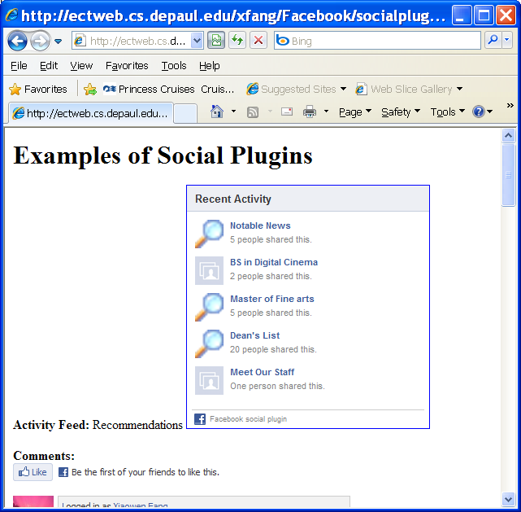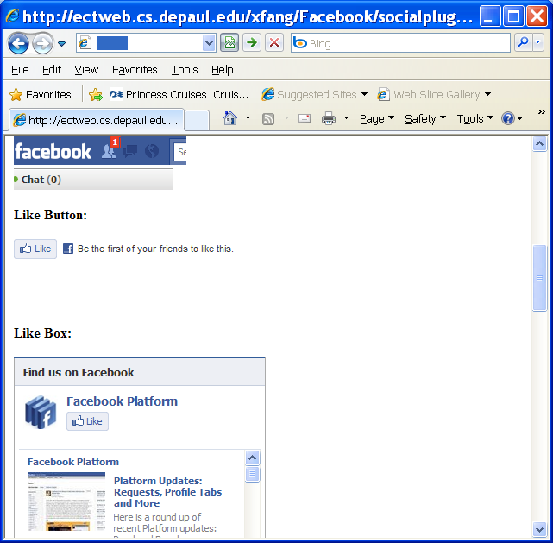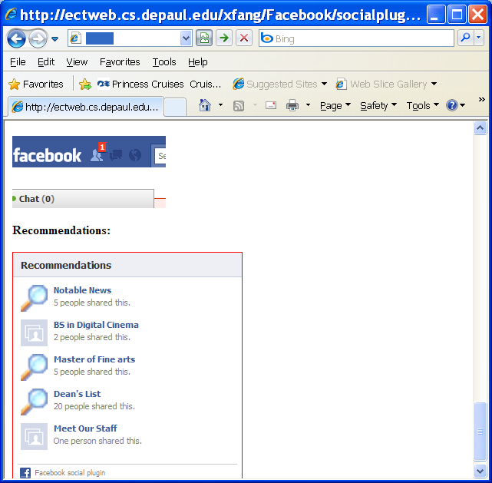
Source code: Facebook/socialplugins.php

<html>
<body>
<h1>Examples of Social Plugins</h1><p>

<b>Activity Feed: </b>
Recommendations

<iframe src="http://www.facebook.com/plugins/activity.php?site=www.cdm.depaul.edu&amp;width=300&amp;height=300&amp;header=true&amp;colorscheme=light&amp;font=arial&amp;border_color=blue&amp;recommendations=true" scrolling="no" frameborder="0" style="border:none; overflow:hidden; width:300px; height:300px;" allowTransparency="true"></iframe>

<p><b>Comments: </b>
<div id="fb-root"></div><script src="http://connect.facebook.net/en_US/all.js#appId=APP_ID&amp;xfbml=1"></script><fb:comments xid="164094916936336" width="425"></fb:comments>
<p><b>Facepile: </b>
<div id="fb-root"></div><script src="http://connect.facebook.net/en_US/all.js#appId=APP_ID&amp;xfbml=1"></script><fb:facepile max-rows="3"></fb:facepile>
<p><b>Like Button: </b></p>
<iframe src="http://www.facebook.com/plugins/like.php?href=http%3A%2F%2Fwww.cdm.depaul.edu&amp;layout=standard&amp;show_faces=true&amp;width=450&amp;action=like&amp;font=lucida+grande&amp;colorscheme=light&amp;height=80" scrolling="no" frameborder="0" style="border:none; overflow:hidden; width:450px; height:80px;" allowTransparency="true"></iframe>
<p><b>Like Box: </b></p>
<iframe src="http://www.facebook.com/plugins/likebox.php?href=http%3A%2F%2Fwww.facebook.com%2Fplatform&amp;width=292&amp;colorscheme=light&amp;connections=10&amp;stream=true&amp;header=true&amp;height=587" scrolling="no" frameborder="0" style="border:none; overflow:hidden; width:292px; height:587px;" allowTransparency="true"></iframe>
<p><b>Live Stream: </b></p>
<iframe src="http://www.facebook.com/plugins/live_stream_box.php?app_id=164094916936336&amp;width=400&amp;height=500&amp;via_url=http%3A%2F%2Fwww.cdm.depaul.edu&amp;always_post_to_friends=true" scrolling="no" frameborder="0" style="border:none; overflow:hidden; width:400px; height:500px;" allowTransparency="true"></iframe>
<p><b>Login Button: </b></p>
<div id="fb-root"></div><script src="http://connect.facebook.net/en_US/all.js#appId=APP_ID&amp;xfbml=1"></script><fb:login-button show-faces="true"></fb:login-button>
<p><b>Recommendations: </b></p>
<iframe src="http://www.facebook.com/plugins/recommendations.php?site=http%3A%2F%2Fwww.cdm.depaul.edu&amp;width=300&amp;height=300&amp;header=true&amp;colorscheme=light&amp;font=tahoma&amp;border_color=red" scrolling="no" frameborder="0" style="border:none; overflow:hidden; width:300px; height:300px;" allowTransparency="true"></iframe>

</body>

</html>

Open Graph protocol
The Open Graph protocol enables you to integrate your pages into the social graph. These pages gain the functionality of other graph objects including profile links and stream updates for connected users.

